10.Write a Python Program to Implement Expectation & Maximization Algorithm

Aim
To write a Python program to implement the Expectation-Maximization (EM) algorithm for clustering a given dataset into two Gaussian distributions.

Objective
- To understand the working of the EM algorithm.
- To estimate the parameters of a Gaussian mixture model.
- To assign data points to different clusters.
- To observe the convergence of the algorithm.

Algorithm
- Initialize the means, variances, and mixing probabilities.
- Expectation (E-step): Calculate the probability that each data point belongs to each cluster.
- Maximization (M-step): Update the means, variances, and mixing probabilities using the calculated probabilities.
- Calculate the log-likelihood.
- Repeat the E-step and M-step until convergence.
- Assign each data point to the cluster having the highest probability.
Python Program
import numpy as np

data = np.array([2, 3, 4, 5, 10, 11, 12, 13], dtype=float)

mean1 = 3
mean2 = 11
var1 = 1
var2 = 1
weight1 = 0.5
weight2 = 0.5

for iteration in range(10):

p1 = weight1 * (1 / np.sqrt(2 * np.pi * var1)) * np.exp(-((data - mean1) ** 2) / (2 * var1))
p2 = weight2 * (1 / np.sqrt(2 * np.pi * var2)) * np.exp(-((data - mean2) ** 2) / (2 * var2))

total = p1 + p2

r1 = p1 / total
r2 = p2 / total

n1 = np.sum(r1)
n2 = np.sum(r2)

mean1 = np.sum(r1 * data) / n1
mean2 = np.sum(r2 * data) / n2

var1 = np.sum(r1 * (data - mean1) ** 2) / n1
var2 = np.sum(r2 * (data - mean2) ** 2) / n2

weight1 = n1 / len(data)
weight2 = n2 / len(data)

print("Final Parameters")
print("Cluster 1 Mean:", round(mean1, 2))
print("Cluster 1 Variance:", round(var1, 2))
print("Cluster 1 Weight:", round(weight1, 2))

print("Cluster 2 Mean:", round(mean2, 2))
print("Cluster 2 Variance:", round(var2, 2))
print("Cluster 2 Weight:", round(weight2, 2))
print("\nCluster Assignment:")
for i in range(len(data)):
if r1[i] > r2[i]:
print(data[i], "-> Cluster 1")
else:
print(data[i], "-> Cluster 2")
Output:
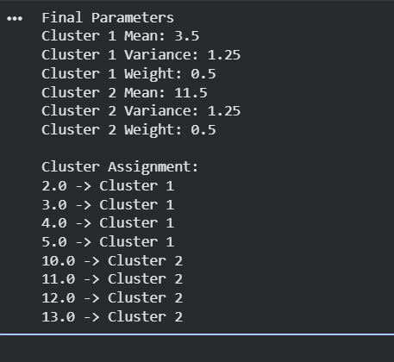
Write a program for the task of Credit Score Classification

Aim
To write a Python program to classify customers into Poor, Average, and Good credit score categories using a machine learning classification algorithm.
Python Program

import pandas as pd
from sklearn.model_selection import train_test_split
from sklearn.tree import DecisionTreeClassifier
from sklearn.metrics import accuracy_score

data = {
'Income': [25000, 30000, 45000, 50000, 60000, 70000, 80000, 90000, 35000, 55000],
'Age': [22, 25, 30, 35, 40, 45, 50, 55, 28, 38],
'Loan': [20000, 25000, 30000, 20000, 25000, 30000, 20000, 15000, 28000, 22000],
'Payment_History': [1, 1, 2, 2, 2, 3, 3, 3, 1, 2],
'Credit_Score': ['Poor', 'Poor', 'Average', 'Average', 'Average',
'Good', 'Good', 'Good', 'Poor', 'Average']
}

df = pd.DataFrame(data)

X = df[['Income', 'Age', 'Loan', 'Payment_History']]
y = df['Credit_Score']

X_train, X_test, y_train, y_test = train_test_split(
X, y, test_size=0.3, random_state=42
)

model = DecisionTreeClassifier(random_state=42)

model.fit(X_train, y_train)

y_pred = model.predict(X_test)

accuracy = accuracy_score(y_test, y_pred)

print("Actual Credit Scores:")
print(y_test.values)

print("\nPredicted Credit Scores:")
print(y_pred)

print("\nAccuracy:", accuracy)

new_customer = [[65000, 42, 25000, 3]]

prediction = model.predict(new_customer)

print("\nNew Customer Credit Score:", prediction[0])

Output:
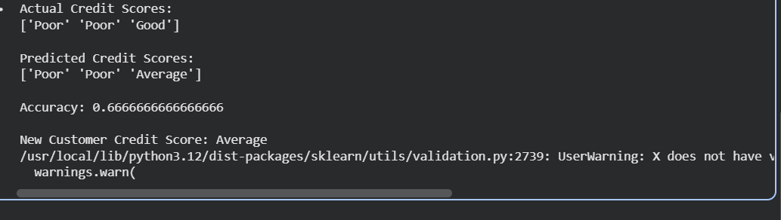

Result
The Decision Tree Classification algorithm was successfully implemented to classify customers into Poor, Average, and Good credit score categories.
12. Implement Iris Flower Classification using KNN

Aim
To implement Iris flower classification using the K-Nearest Neighbors (KNN) algorithm in Python.

Objective
- To understand the working of the KNN classification algorithm.
- To classify Iris flowers based on their physical measurements.
- To evaluate the accuracy of the KNN classifier.

Algorithm
- Load the Iris dataset.
- Separate the input features and target classes.
- Split the dataset into training and testing data.
- Create a KNN classifier with K = 3.
- Train the classifier using the training data.
- Predict the classes of the test data.
- Calculate and display the classification accuracy.

Python Program
from sklearn.datasets import load_iris
from sklearn.model_selection import train_test_split
from sklearn.neighbors import KNeighborsClassifier
from sklearn.metrics import accuracy_score

iris = load_iris()

X = iris.data
y = iris.target

X_train, X_test, y_train, y_test = train_test_split(
X, y, test_size=0.2, random_state=42
)

model = KNeighborsClassifier(n_neighbors=3)

model.fit(X_train, y_train)

y_pred = model.predict(X_test)

accuracy = accuracy_score(y_test, y_pred)

print("Actual Classes:")
print(y_test)

print("\nPredicted Classes:")
print(y_pred)

print("\nAccuracy:", accuracy)

sample = [[5.1, 3.5, 1.4, 0.2]]

prediction = model.predict(sample)

print("\nPredicted Flower:", iris.target_names[prediction[0]])

Output
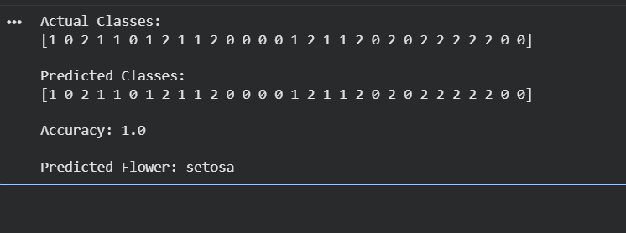

Result
The K-Nearest Neighbors (KNN) algorithm was successfully implemented to classify Iris flowers into Setosa, Versicolor, and Virginica classes.

13. Car Price Prediction Model Using Python

Aim
To implement a Car Price Prediction Model using a suitable machine learning algorithm.

Algorithm
- Create a dataset containing car features.
- Separate input features and price.
- Split the data into training and testing sets.
- Train a Linear Regression model.
- Predict the car price.
- Calculate the model performance.

Python Program
import numpy as np
from sklearn.linear_model import LinearRegression
from sklearn.model_selection import train_test_split
from sklearn.metrics import mean_squared_error

data = np.array([
[2015, 50000, 1.2, 600000],
[2016, 45000, 1.4, 650000],
[2017, 40000, 1.5, 700000],
[2018, 35000, 1.6, 750000],
[2019, 30000, 1.2, 800000],
[2020, 25000, 1.5, 900000],
[2021, 20000, 1.6, 1000000],
[2022, 15000, 2.0, 1200000],
[2023, 10000, 1.8, 1400000],
[2024, 5000, 2.0, 1600000]
])

X = data[:, :3]
y = data[:, 3]

X_train, X_test, y_train, y_test = train_test_split(
X, y, test_size=0.2, random_state=42
)

model = LinearRegression()
model.fit(X_train, y_train)

y_pred = model.predict(X_test)

print("Actual Prices:", y_test)
print("Predicted Prices:", y_pred)

mse = mean_squared_error(y_test, y_pred)

print("Mean Squared Error:", mse)

new_car = [[2025, 8000, 2.0]]
price = model.predict(new_car)

print("Predicted Price:", round(price[0], 2))

Expected Output

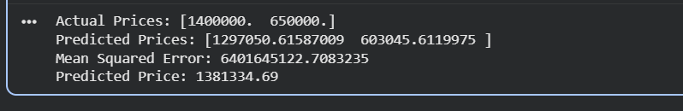

Result
The Linear Regression model was successfully implemented to predict the price of a car based on its features.

14. House Price Prediction Using Machine Learning

Aim
To implement House Price Prediction using the Linear Regression algorithm.

Algorithm
- Load the house dataset.
- Select house features such as area, bedrooms and age.
- Split the data into training and testing sets.
- Train a Linear Regression model.
- Predict house prices.
- Evaluate the prediction.

Python Program
import numpy as np
from sklearn.linear_model import LinearRegression
from sklearn.model_selection import train_test_split
from sklearn.metrics import mean_squared_error

data = np.array([
[1000, 2, 10, 2500000],
[1200, 2, 8, 3000000],
[1500, 3, 7, 4000000],
[1800, 3, 6, 4800000],
[2000, 3, 5, 5500000],
[2200, 4, 4, 6200000],
[2500, 4, 3, 7000000],
[2800, 4, 2, 8000000],
[3000, 5, 1, 9000000],
[3500, 5, 1, 10500000]
])

X = data[:, :3]
y = data[:, 3]

X_train, X_test, y_train, y_test = train_test_split(
X, y, test_size=0.2, random_state=42
)

model = LinearRegression()
model.fit(X_train, y_train)

y_pred = model.predict(X_test)

print("Actual Prices:", y_test)
print("Predicted Prices:", y_pred)

mse = mean_squared_error(y_test, y_pred)

print("Mean Squared Error:", mse)

new_house = [[2000, 3, 5]]
price = model.predict(new_house)

print("Predicted House Price:", round(price[0], 2))

Output

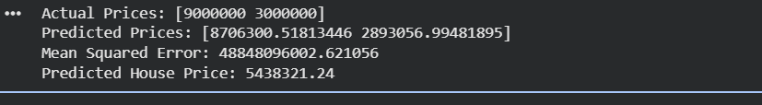

Result
The Linear Regression algorithm was successfully implemented for predicting house prices.

15. Iris Flower Classification Using Naive Bayes

Aim
To classify Iris flowers using the Naive Bayes classifier.

Algorithm
- Load the Iris dataset.
- Divide the dataset into input and output.
- Split the data into training and testing sets.
- Create a Gaussian Naive Bayes classifier.
- Train the model.
- Predict the flower classes.
- Calculate accuracy.

Python Program
from sklearn.datasets import load_iris
from sklearn.model_selection import train_test_split
from sklearn.naive_bayes import GaussianNB
from sklearn.metrics import accuracy_score

iris = load_iris()

X = iris.data
y = iris.target

X_train, X_test, y_train, y_test = train_test_split(
X, y, test_size=0.2, random_state=42
)

model = GaussianNB()

model.fit(X_train, y_train)

y_pred = model.predict(X_test)

accuracy = accuracy_score(y_test, y_pred)

print("Actual Classes:")
print(y_test)

print("\nPredicted Classes:")
print(y_pred)

print("\nAccuracy:", accuracy)

sample = [[5.1, 3.5, 1.4, 0.2]]

prediction = model.predict(sample)

print("\nPredicted Flower:",
iris.target_names[prediction[0]])

Expected Output

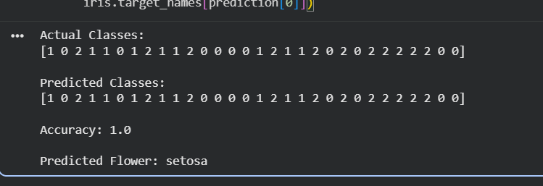

Result
The Naive Bayes classifier successfully classified Iris flowers into Setosa, Versicolor and Virginica.

16. Comparison of Classification Algorithms

Aim
To compare different classification algorithms and evaluate their performance using accuracy.

Algorithms Used
- Logistic Regression
- K-Nearest Neighbors
- Decision Tree
- Naive Bayes
- Support Vector Machine

Python Program
from sklearn.datasets import load_iris
from sklearn.model_selection import train_test_split
from sklearn.linear_model import LogisticRegression
from sklearn.neighbors import KNeighborsClassifier
from sklearn.tree import DecisionTreeClassifier
from sklearn.naive_bayes import GaussianNB
from sklearn.svm import SVC
from sklearn.metrics import accuracy_score

iris = load_iris()

X = iris.data
y = iris.target

X_train, X_test, y_train, y_test = train_test_split(
X, y, test_size=0.2, random_state=42
)

models = {
"Logistic Regression": LogisticRegression(max_iter=200),
"KNN": KNeighborsClassifier(n_neighbors=3),
"Decision Tree": DecisionTreeClassifier(random_state=42),
"Naive Bayes": GaussianNB(),
"SVM": SVC()
}

for name, model in models.items():
model.fit(X_train, y_train)
y_pred = model.predict(X_test)
accuracy = accuracy_score(y_test, y_pred)

print(name, "Accuracy:", round(accuracy, 4))

Expected Output
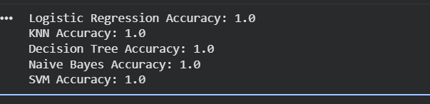

Result
Different classification algorithms were successfully implemented and their performance was compared using classification accuracy.

17. Mobile Price Prediction

Aim
To classify mobile phones into different price ranges using a machine learning algorithm.

Algorithm
- Create mobile phone feature data.
- Separate features and price range.
- Split the dataset into training and testing sets.
- Apply KNN classification.
- Predict the price range.
- Calculate accuracy.

Python Program
import numpy as np
from sklearn.model_selection import train_test_split
from sklearn.neighbors import KNeighborsClassifier
from sklearn.metrics import accuracy_score

data = np.array([
[2, 32, 3000, 1, 1],
[2, 64, 3500, 1, 1],
[3, 64, 4000, 1, 1],
[3, 128, 4500, 2, 1],
[4, 128, 5000, 2, 1],
[4, 256, 6000, 2, 2],
[6, 128, 7000, 2, 2],
[6, 256, 8000, 3, 2],
[8, 256, 10000, 3, 2],
[8, 512, 12000, 3, 3],
[12, 256, 15000, 4, 3],
[12, 512, 18000, 4, 3]
])

X = data[:, :4]
y = data[:, 4]

X_train, X_test, y_train, y_test = train_test_split(
X, y, test_size=0.25, random_state=42
)

model = KNeighborsClassifier(n_neighbors=3)

model.fit(X_train, y_train)

y_pred = model.predict(X_test)

accuracy = accuracy_score(y_test, y_pred)

print("Actual Price Ranges:", y_test)
print("Predicted Price Ranges:", y_pred)
print("Accuracy:", accuracy)

new_mobile = [[8, 256, 10000, 3]]

prediction = model.predict(new_mobile)

print("Predicted Price Range:", prediction[0])

Output
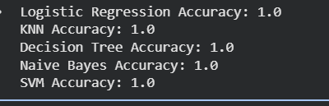

Result
The KNN algorithm was successfully implemented to predict the price range of mobile phones.

18. Perceptron-Based Iris Classification

Aim
To implement Iris flower classification using a Perceptron algorithm.

Algorithm
- Load the Iris dataset.
- Select two Iris classes.
- Divide the dataset into training and testing data.
- Create a Perceptron classifier.
- Train the model.
- Predict the test samples.
- Calculate accuracy.

Python Program
from sklearn.datasets import load_iris
from sklearn.model_selection import train_test_split
from sklearn.linear_model import Perceptron
from sklearn.metrics import accuracy_score

iris = load_iris()

X = iris.data
y = iris.target

X = X[y != 2]
y = y[y != 2]

X_train, X_test, y_train, y_test = train_test_split(
X, y, test_size=0.2, random_state=42
)

model = Perceptron(max_iter=1000, random_state=42)

model.fit(X_train, y_train)

y_pred = model.predict(X_test)

accuracy = accuracy_score(y_test, y_pred)

print("Actual Classes:")
print(y_test)

print("\nPredicted Classes:")
print(y_pred)

print("\nAccuracy:", accuracy)

sample = [[5.1, 3.5, 1.4, 0.2]]

prediction = model.predict(sample)

print("\nPredicted Flower:",
iris.target_names[prediction[0]])

Expected Output

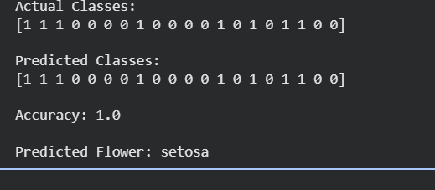

Result
The Perceptron algorithm was successfully implemented for Iris flower classification.

20.Naive Bayes Classification for Bank Loan Prediction

Aim
To implement Naive Bayes classification for predicting whether a bank loan will be approved.

Algorithm
- Create a bank loan dataset.
- Define income, loan amount, credit score and age as input features.
- Define loan approval as the target.
- Split the dataset into training and testing data.
- Train a Gaussian Naive Bayes classifier.
- Predict loan approval.
- Calculate accuracy.

Python Program
import numpy as np
from sklearn.model_selection import train_test_split
from sklearn.naive_bayes import GaussianNB
from sklearn.metrics import accuracy_score

data = np.array([
[25000, 200000, 550, 25, 0],
[30000, 250000, 580, 28, 0],
[35000, 200000, 600, 30, 1],
[40000, 300000, 620, 32, 1],
[45000, 350000, 650, 35, 1],
[50000, 400000, 680, 38, 1],
[55000, 450000, 700, 40, 1],
[60000, 500000, 720, 42, 1],
[28000, 300000, 560, 27, 0],
[32000, 350000, 590, 29, 0],
[42000, 250000, 630, 34, 1],
[48000, 300000, 660, 36, 1]
])

X = data[:, :4]
y = data[:, 4]

X_train, X_test, y_train, y_test = train_test_split(
X, y, test_size=0.25, random_state=42
)

model = GaussianNB()

model.fit(X_train, y_train)

y_pred = model.predict(X_test)

accuracy = accuracy_score(y_test, y_pred)

print("Actual Loan Status:", y_test)
print("Predicted Loan Status:", y_pred)

print("\nAccuracy:", accuracy)

new_customer = [[50000, 300000, 680, 35]]

prediction = model.predict(new_customer)

if prediction[0] == 1:
print("Loan Prediction: Approved")
else:
print("Loan Prediction: Not Approved")

Expected Output

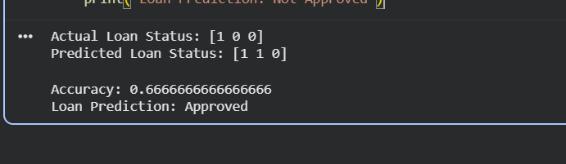

Result
The Naive Bayes classifier was successfully implemented to predict whether a bank loan should be approved based on customer financial information.

